Request for the creation of a new research project at AZSTM  
- Instructions -

Important things to know before requesting the creation of a new research project

**Dyco Flow is an interactive data and document capture software managing the submission of clinical research studies that is shared by all involved parties.**

The submission of a clinical research project involving AZSTM patients is processed exclusively via **Dyco Flow**.

The review of the **clinical trial contract** is fully integrated within the submission of the project and managed through Dyco Flow. The hospital will inform you via Dyco Flow whenever they are ready to begin the process.   
**Do not share/upload any contract related document prior to having been invited to do so by the hospital**.

**No emails**. AZSTM will only accept documents that are uploaded in the Dyco Flow platform.

**Retrospective studies** can only be carried out using residual human body material previously stored in a **registered biobank** and/or using data entered in an **AZSTM approved registry** (the procedure for approval of registry is done via Dyco Flow)

Note that **case reports are not studies** and are submitted directly to the EC.

**User’s instruction guides have been written to allow you to perform a smooth and prompt submission**. They are available online within the Dyco Flow webpage. Use them at all time.

Table of Content

A. Completing the New Study Request Form

B. Sending the New study Request Form

C. Important information for new users of the AZSTM Dyco Flow platform

1. Completing the sponsor new Study Request Form

|  |  |  |  |  |
| --- | --- | --- | --- | --- |
| **NEW STUDY REQUEST FORM** | | | | |
| **Original title** |  | | | |
| **Department** | | |  | |
| **Supporting Department** (1) | | |  | |
| **Supporting Department** (1) | | |  | |
| **Supporting Department** (1) | | |  | |
| **Supporting Department** (1) | | |  | |
| **Project type: Level 0** (2) | | |  | |
| **Project type: Level 1** (2) | | |  | |
| **Project type: Level 2** (2) | | |  | |
| **Project type: Level 3** (2) | | |  | |
| **Project type: Level 4** (2) | | |  | |
| **Investigational medicinal product (class 3a**) (2) | | |  | |
| **Submission Users** | | **First name** | **Last name** | **Email address** (3) | |
| Project Submitter (likely you) (4) | |  |  |  | |
| Principal investigator | |  |  |  | |
| **Contract Management Users** (5) | | **First name** | **Last name** | **Email address** (3) | |
| Contract Submitter (6) | |  |  |  | |

**Instructions for completing the NEW STUDY REQUEST FORM**

1. Enter only the supporting departments that apply, if none left it blank (= Dropdown list).
2. Complete the Project Type using the chart below. Enter only values that apply, if none left it blank (NA = “Dropdown list”):   
   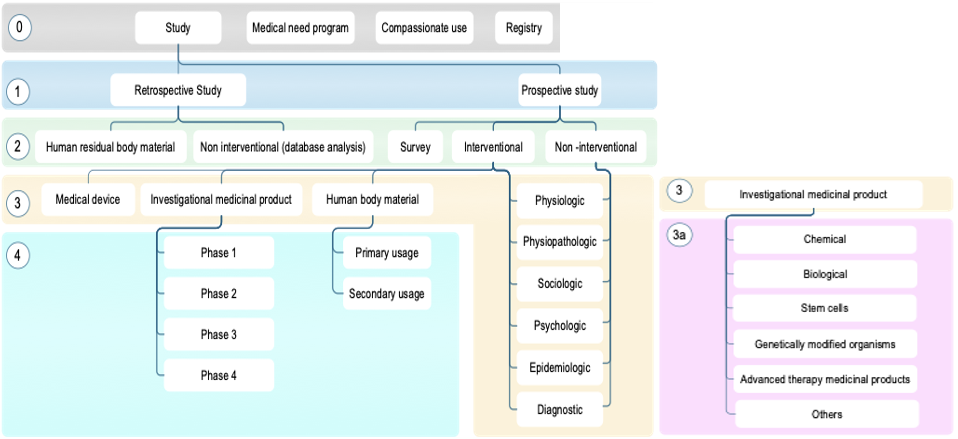
3. Incorrect emails = blocked project (because email addresses are used as login).
4. The project submitter is usually the person that fills the form, he is in charge of completing the submission to the EC
5. Only if there is a contract in the project. The contract management users are users involved in the negotiation of the contract.
6. The contract “Submitter” is the user in charge of managing the execution of the main contract **on the side of the sponsor.** The contract submitter and the Project submitter can be the same user.
7. Sending the New study Request Form
8. Attach this completed document to an email addressed to inez.mestdagh@emmaus.be , katrien.beullens@emmaus.be and sofie.drieghe@emmaus.be. In the email subject tab write: “**Dyco Flow-INPUT REQUIRED: create a new project**”.
9. You will receive an email from “**no_reply_AZSTM_Dyco_Flow@digidyco.com”** inviting you to login onto your clinical research project (pass the text if any and go to the bottom of the message to find the link).
10. Login. Before you begin, **make sure that POP-UP WINDOWS are activated in your browser** (go to the internet to find the appropriate procedure, it is different for each browser).
11. Locate the “**Submitter Support**” tab in the main ribbon, click on it (see print screen home page below) and start by opening the document called “WHAT TO DO AND DOCUMENTS TO COLLECT”. Read it carefully. Follow all the instructions. Once you are done open “INITIAL DOCUMENT SUBMISSION” and proceed as instructed. You will be guided step by step toward the completion of your submission through the Dyco Flow user instruction manuals that are in the “**Submitter support**” tab.

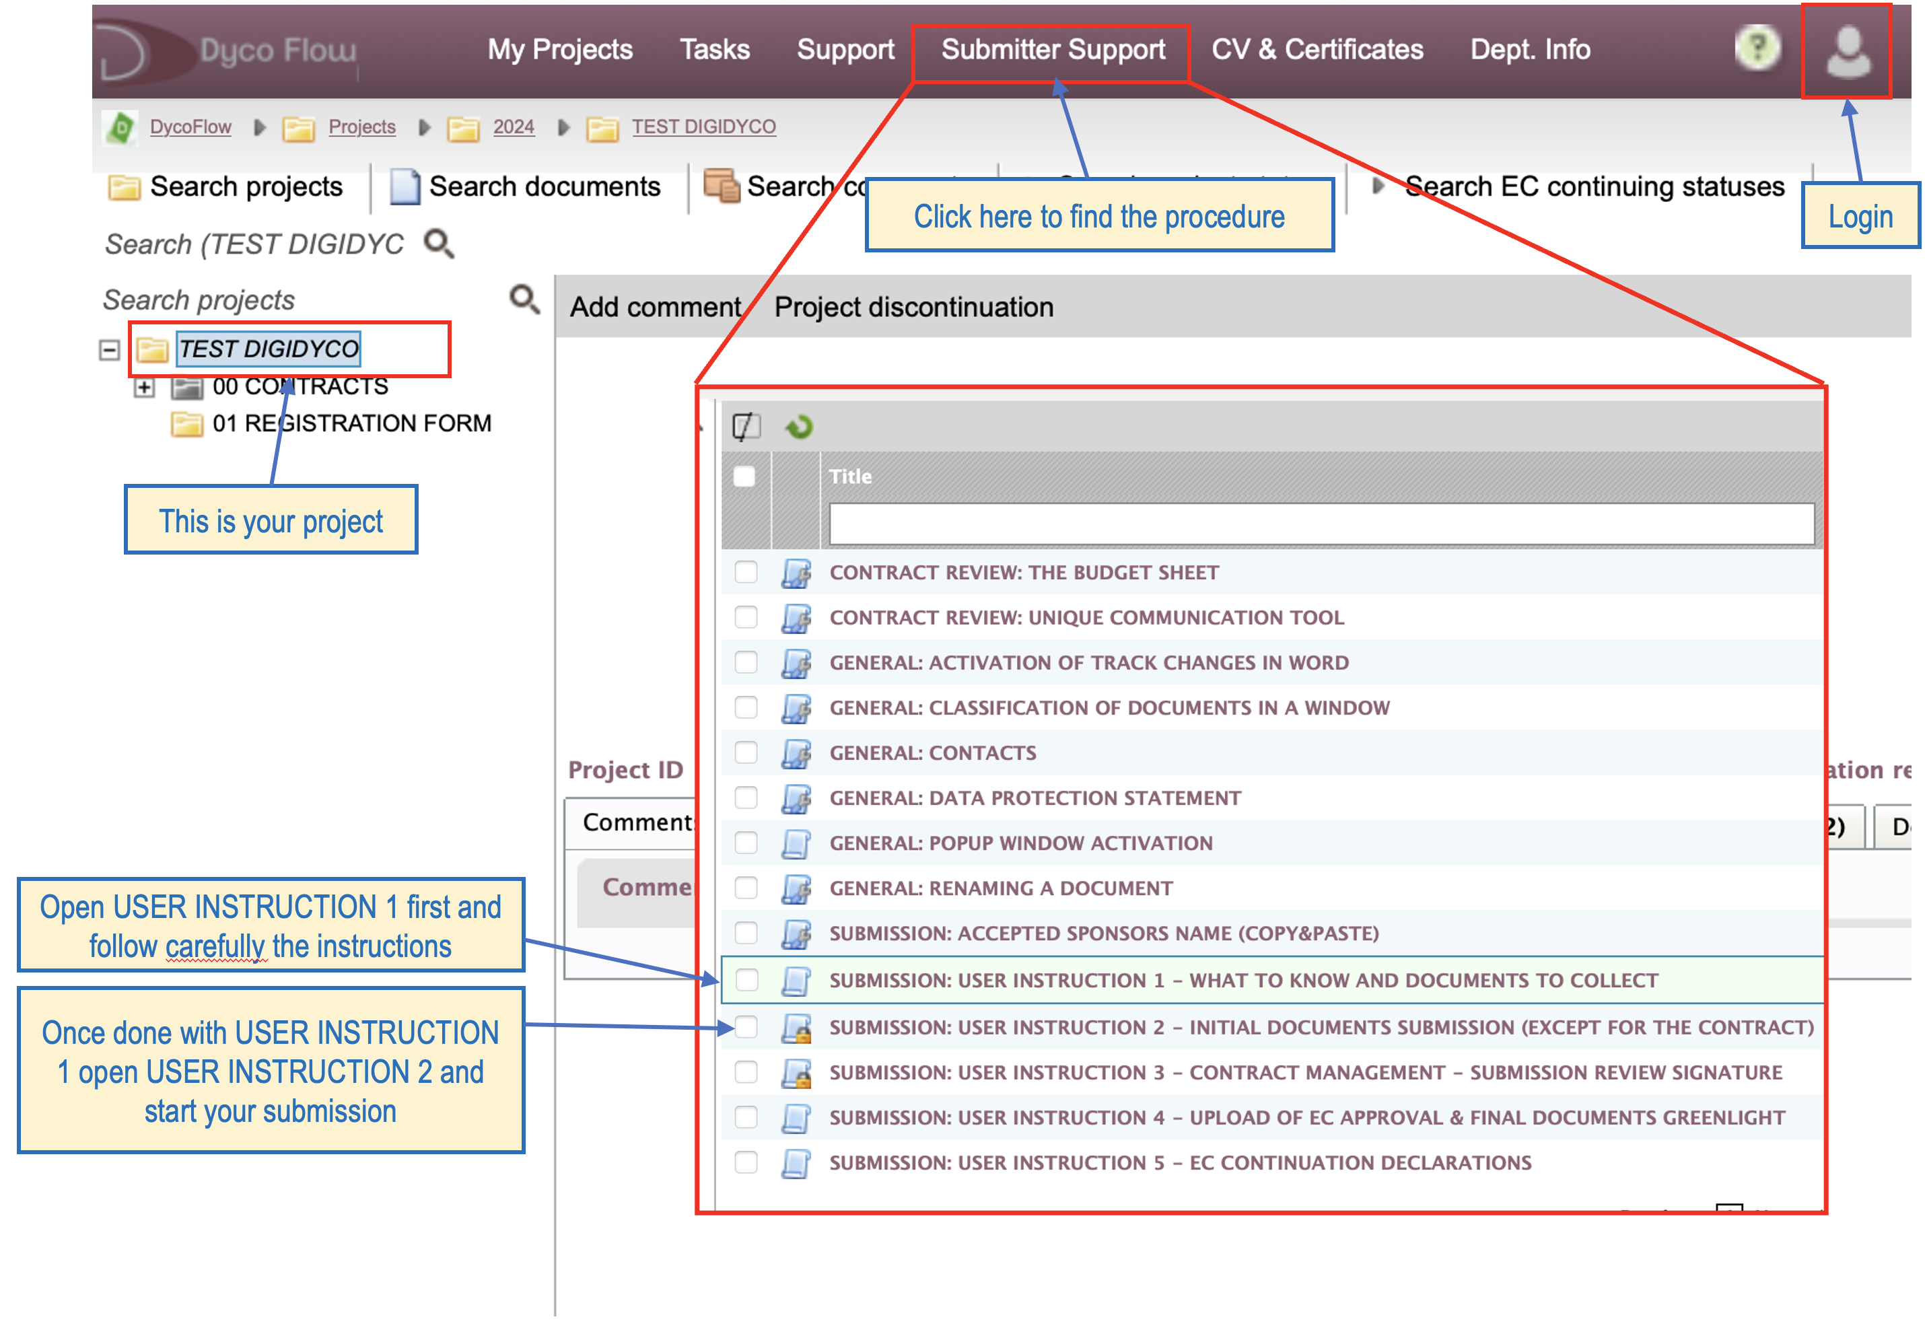

1. Important information for new users of the AZSTM Dyco Flow platform
2. Dyco Flow has sent you, an email called “**New account login instructions**” containing all the instructions to create your Dyco Flow account.
3. Once you are logged in the platform you will see your project in Dyco Flow.