Submission of a clinical research project
How to request the creation of a new project in Dyco Flow
Version: 20231101

Table of Content
- Introduction
- Important things to consider before beginning
- Instructions

Introduction
The submission of a clinical research project involving AZSTM patients is processed using a digital platform called Dyco Flow. Dyco Flow is an interactive data and document capture software shared by all involved parties.

Important things to consider before beginning.
- Registry submissions are also done through Dyco Flow.
- Case reports do not go through Dyco Flow. They are submitted directly to the EC.
- Analyses of residual human body material or existing patient data are retrospective studies.
- Retrospective studies can only be carried out using residual human body material or data previously stored in registered biobanks or registries, respectively.
- Follow the instructions provided on the following page to register your project in Dyco Flow.

Instructions
- Complete the table below:
Original title | Enter the title
Project type Level 0 (1)
Project type Level 1 (1)
Project type Level 2 (1)
Project type Level 3 (1)
Project type Level 4 (1)
Investigational medicinal product (class 3a) (1)
Department
Supporting Department (2)
Supporting Department (2)
Supporting Department (2)
Supporting Department (2)
Submission Users |  | First name | Last name | Email address (3)
Project Submitter (likely you) (4)
Principal investigator
Contract Management Users (5) |  | First name | Last name | Email address (3)
Contract Submitter (6)
Primary Contact (7)
- Complete the project type using the chart below. Enter only values that apply, if none left it blank (NA = “Dropdown list”):
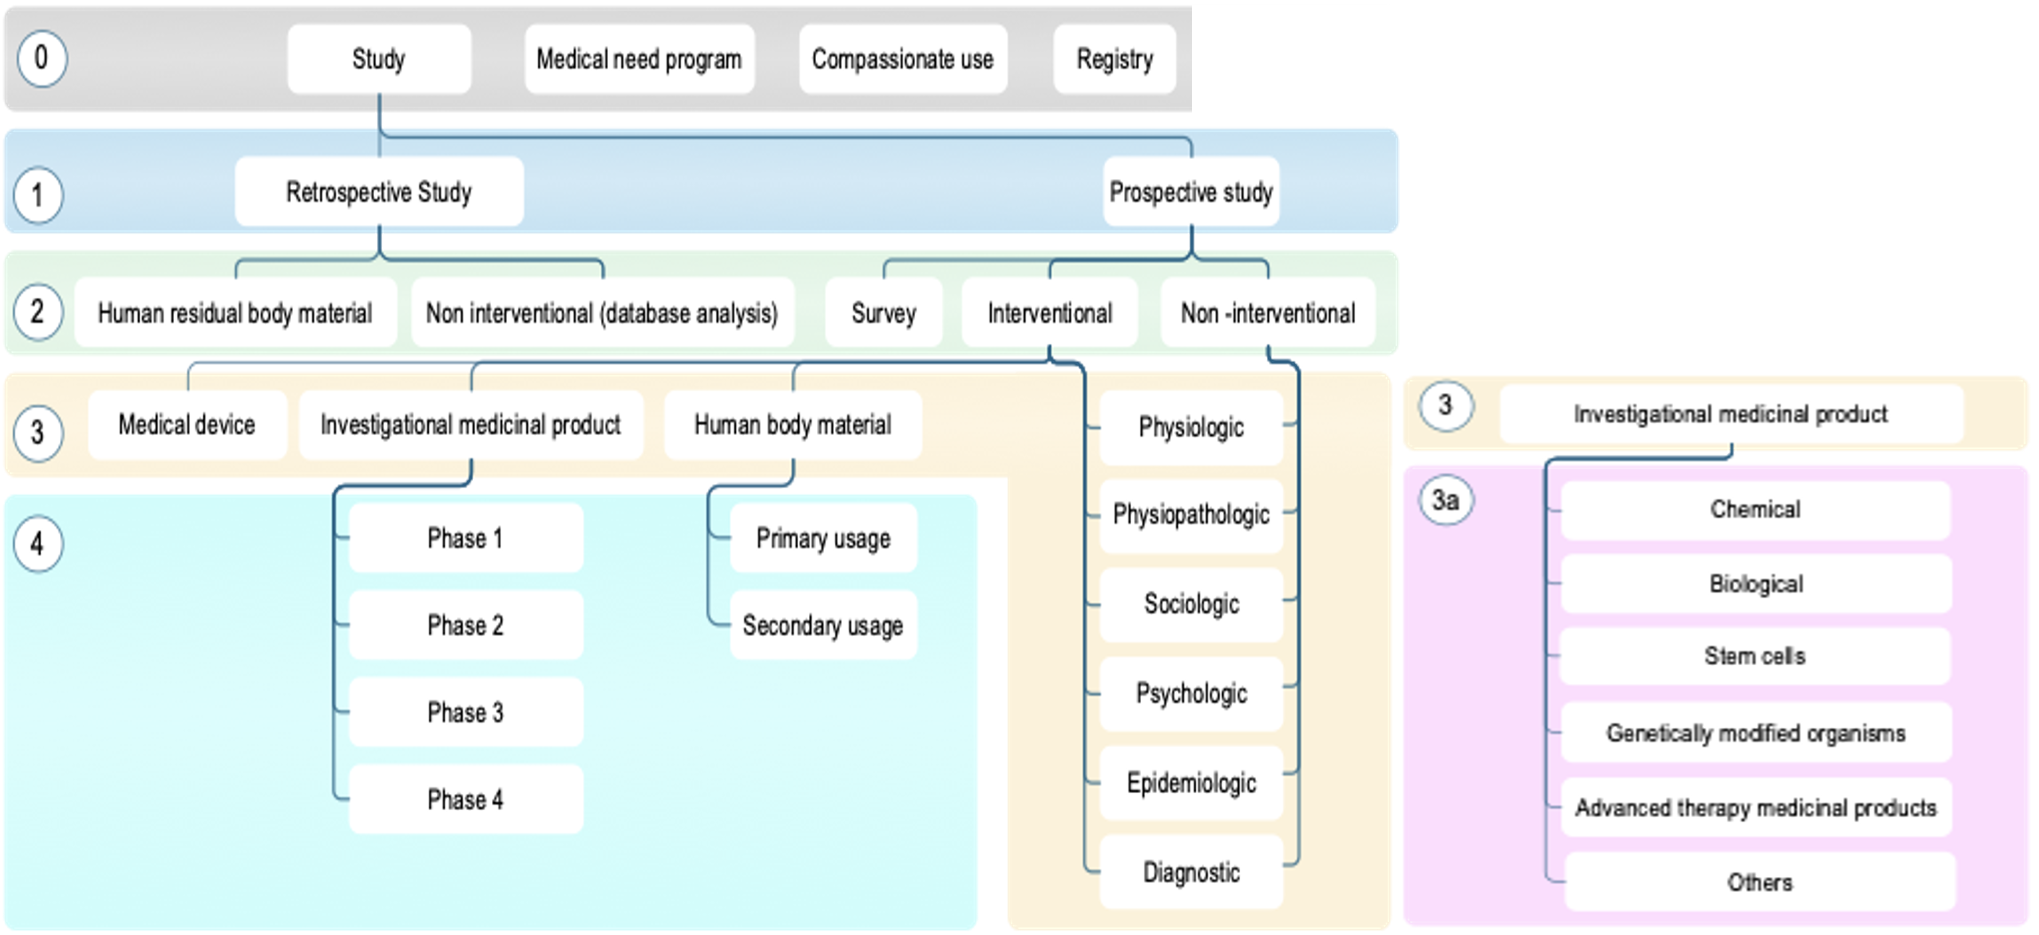
- Enter only the supporting departments that apply, if none left it blank (= Dropdown list).
- Incorrect emails = blocked project (because email addresses are used as login).
- The project submitter is usually the person that fills the form, he is in charge of completing the submission to the EC
- Only if there is a contract in the project. The contract management users are users involved in the negotiation of the contract.
- The contract “Submitter” is the user in charge of managing the execution of the main contract on the side of the sponsor. The contract submitter and the Project submitter can be the same user.
- Enter a “Primary Contact” only if there will be an additional contract (e.g., MTA, CDA, DTA).
- Save the Word document with the completed table and send the document as an attachment of an email, write “Dyco Flow-INPUT REQUIRED: create a new project” in the OBJECT/SUBJECT field of the email and send it to inez.mestdagh@emmaus.be with copy to katrien.beullens@emmaus.be and sofie.drieghe@emmaus.be.

Working with Dyco Flow
Once your project has been created, you will receive an email from “EMMAUS Dyco Flow” to login onto your new project.
For new users only: Dyco Flow has sent you, an email called “New account login instructions” containing all the instructions to create your Dyco Flow account.
IMPORTANT: before you begin, make sure that POP-UP WINDOWS are activated in your browser (go to the internet to find the appropriate procedure, it is different for each browser).
- Log in to the Dyco Flow application.
- You will land on the homepage below.
- Locate the “Submitter Support tab” in the ribbon, click on it and open the document called “DYCOFLOW_MODULE1_VOL2_GETTINGSTARTED”. Follow the instructions.
